**CASESTUDY 1:**

**1. Set Up Azure Blob Storage**

1. **Create Storage Accounts**
2. **Create Containers**
3. **Uploaded Sample Data**

**2. Configure Azure Data Factory**

1. **Create Data Factory:**
2. **Create Linked Services:**
   * **Azure Blob Storage Linked Service:**
3. **Create Datasets:**
   * **Source Dataset:**
   * **Destination Dataset:**

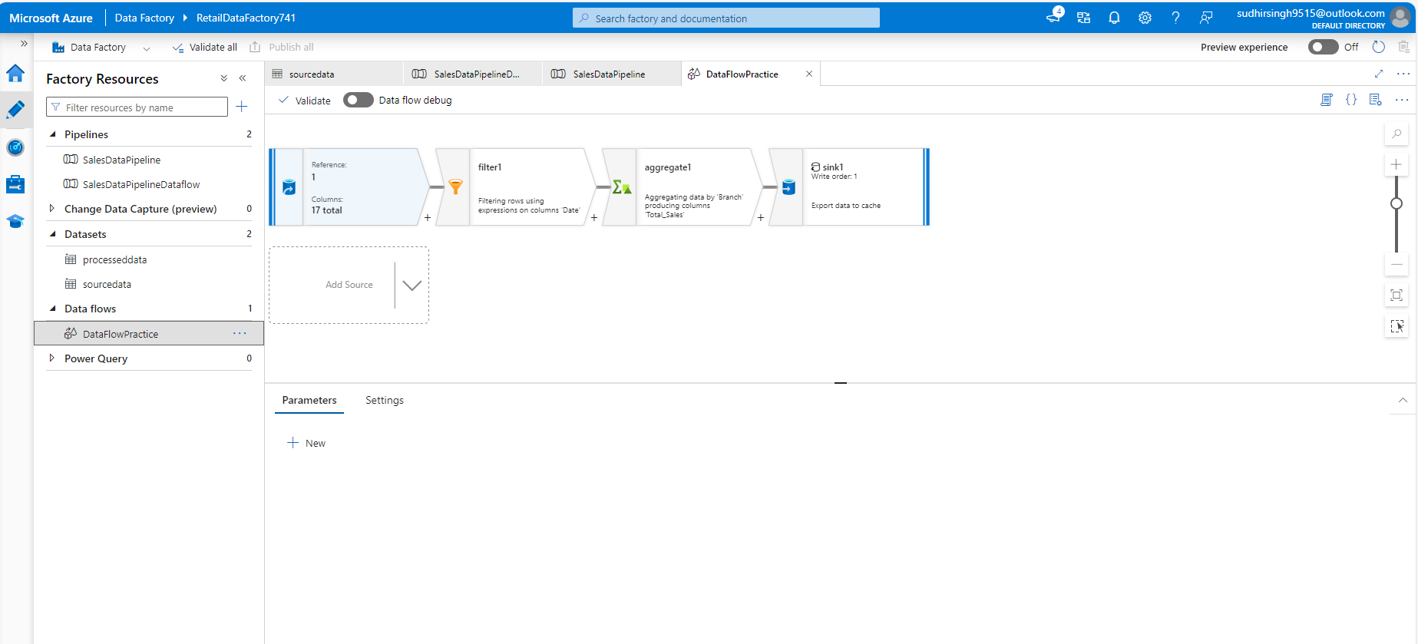

Filter: !isNull(Date)

Aggregate: Group by Branch, sum(Total) as TotalSales

